LAB INTERNAL EXAM
SET B

Anunadh Rajesh
S3MCA
20MCA015

Q1.)
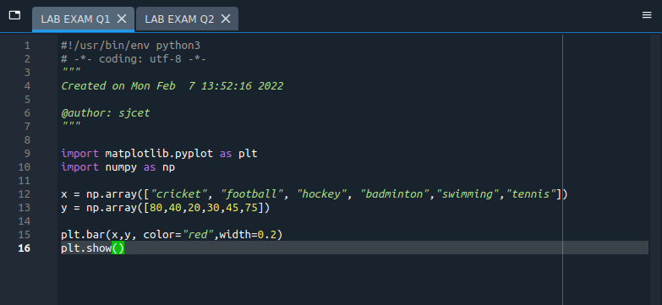
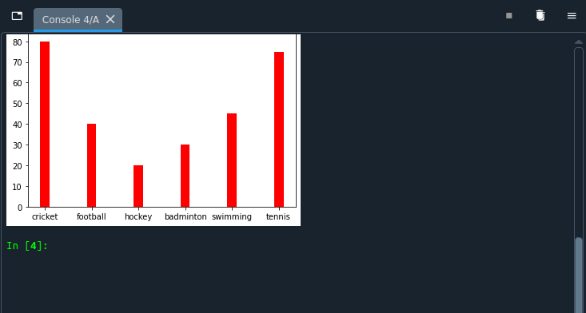
OUTPUT

Q2.)

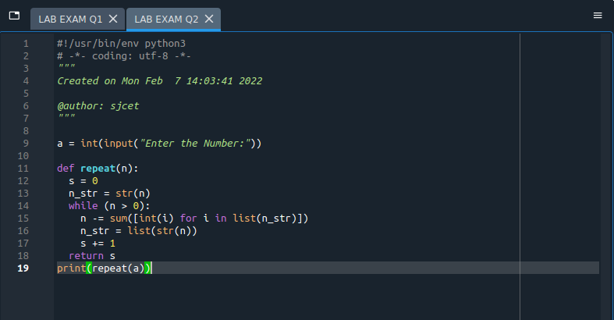
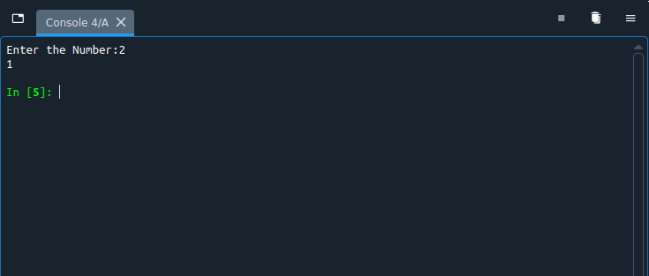
OUTPUT

